**DAILY ONLINE ACTIVITIES SUMMARY**

|  |  |  |  |  |  |  |  |  |
| --- | --- | --- | --- | --- | --- | --- | --- | --- |
| **Date:** | **18/06/2020** | | | | **Name:** | | **Likhitha.M** | |
| **Sem & Sec** | **6th sem ‘A’** | | | | **USN:** | | **4AL17CS046** | |
| **Online Test Summary** | | | | | | | | |
| **Subject** | | **-** | | | | | | |
| **Max. Marks** | | **-** | | **Score** | | | **-** | |
| **Pre-Placement Training Summary** | | | | | | | | |
| **Pre placement training** | **9:00 am to 11:00 am - Programming in C**  **11:00 am to 1:00pm - Applications of python in DA and ML** | | | | | | | |
| **Faculty** | | | **Mr.Vivek Sharma**  **Dr. Mohideen Badusha** | | | **Duration** | | **4 hr** |
| **Assessments** | | | | | | | | |
| **Problem Statement:**   1. Examples and Exercises on python. | | | | | | | | |
| **Status: Completed** | | | | | | | | |
| **Uploaded the report in Github** | | | | | | **Yes** | | |
| **If yes Repository name** | | | | | | [**https://github.com/likhithaMantaral/Python-in-DA_-and_-ML/blob/master/Day4-Session%201-Data%20cleaning%20Exercise.ipynb**](https://github.com/likhithaMantaral/Python-in-DA_-and_-ML/blob/master/Day4-Session%201-Data%20cleaning%20Exercise.ipynb)  **https://github.com/likhithaMantaral/Python-in-DA_-and_-ML/blob/master/Day4%20-%20Session1-Data%20Munging%20Manipulation%20Explonatory%20analysis(case_study2).ipynb** | | |
| **Uploaded the report in slack** | | | | | | **Yes** | | |

**Training snapshots:**

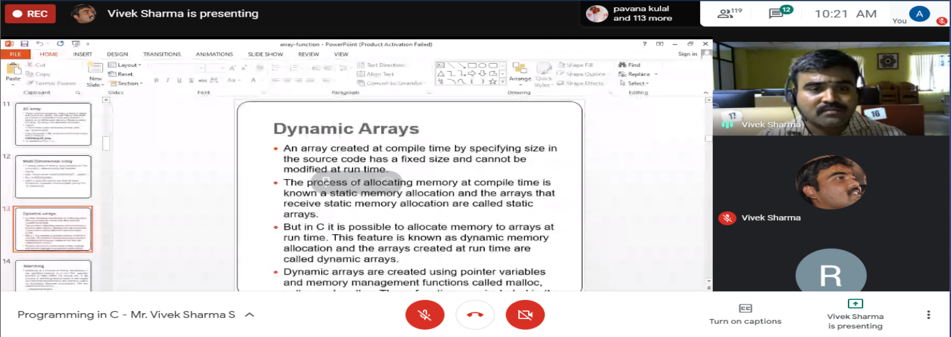

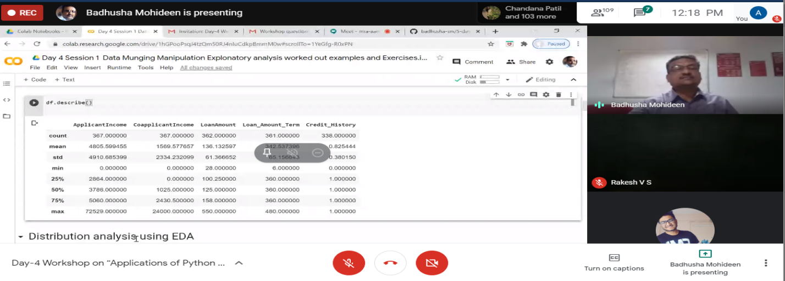

**Assessments:**

**Uploaded in github account and respective link is provided below.**

